Interim COVID 19 Waste Management Measures

Management of healthcare waste from care home settings

Please note that some of the normal waste management practices are adapted to support suitable management of the COVID-19 waste. These adaptions are recognised by National Resource Wales and have been developed in conjunction with the Public Health Wales and Welsh Government. This advice is subject to review and will be updated.
It is important that non-healthcare waste e.g. recycling, domestic type waste, packaging etc must continue to be handled and managed as normal.
Description of Waste | Requirement | Note
Personal contact waste ( includes PPE) from routine care (of all residents) e.g. performing meal rounds, medication rounds,  prompting people to take their medicines, or cleaning close to residents, assisting with getting in/out of bed, feeding, dressing, bathing, grooming, toileting, applying dressings etc | Place in the usual “tiger bag” – a yellow bag with a black stripe. Secure with swan neck and zip tie or tape and store safely or see note.  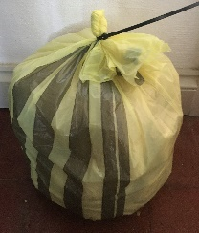  Dispose of as per usual arrangements. | Where you do not have an ‘offensive waste’ stream ‘black bags’ for residual waste disposal can be used.
Offensive Waste –waste contaminated with body fluids from all residents e.g. bodily fluids, incontinence waste, stoma bags etc | Place in the usual “tiger bag” – a yellow bag with a black stripe. Secure with swan neck and zip tie or tape and store safely  Dispose of as per usual arrangements. | Where possible urine and faeces collected in vessels/mobile toilets shall be flushed to sewer.  Where macerators are routinely used, their use may be continued.
Where a resident is suspected or confirmed of having COVID-19 and you can securely store for at least 72hrs for the specified wastes below:  Respiratory Intervention waste Suction catheters and other waste contaminated with respiratory secretions generated from the care of residents with a tracheostomy or long-term ventilation.  Personal contact waste  Used tissues, and other soiled items, discarded PPE and disposable cleaning cloths | Place in the usual “tiger bag” – a yellow bag with a black stripe. Secure with swan neck and zip tie or tape and store safely.  This should be securely stored for at least 72 hours before being put in your usual collected waste bin and disposed of as per usual arrangements. If this is not possible please follow guidance below. | If using this option, you must have clear and clearly displayed procedures to ensure good segregation from other tiger bag waste detailed in this table.  You should maintain written records to demonstrate the waste has been held for 72hrs.
Where a resident is suspected or confirmed of having COVID-19 and you cannot securely store for at least 72hrs for the specified wastes below:  Respiratory Intervention waste Suction catheters and other waste contaminated with respiratory secretions generated from the care of residents with a tracheostomy or long-term ventilation  Personal contact waste  Used tissues, and other soiled items, discarded PPE and disposable cleaning cloths | Place in an orange bag. Secure with swan neck and zip tie or tape and store safely.  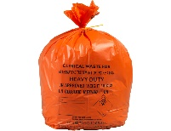  Dispose of as infectious clinical waste
Other Clinical Waste  Associated with treatment of individuals – this may include other infectious waste from other treatments, Sharps, pharmaceuticals | This waste requires require specialist disposal and should be managed in line with the advice given in Welsh Health Technical Memorandum. 07-01: Safe management of healthcare waste.  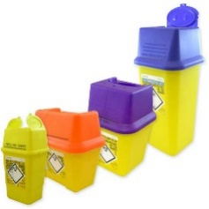  This guidance can be found here:  http://www.wales.nhs.uk/sites3/documents/254/whtm%2007-01.pdf  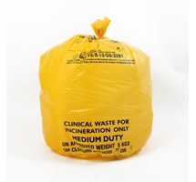 | Your clinical waste contractor should be able to give you advice also and help you get this right.

